Приложение.
S1. Координаты (Å) и значение полной энергии (a.u.) молекулы 1, оптимизированной методом DFT/B3LYP/6-31G(d,p).
Cartesian coordinates (Å) and total energy value (a.u.) of 1 optimized at the DFT/B3LYP/6-31G(d,p) level.
Атом x y z
N 5.931646417 3.360728281 5.888633691
H 4.992405172 3.121262412 6.174256818
N 7.866205265 4.511914481 6.487114164
N 5.812412508 4.725126140 7.732209468
C 6.571651884 4.224017472 6.728882387
C 6.419109694 5.593263149 8.538479715
H 5.811189447 5.998381756 9.347106881
C 7.752506957 5.978600598 8.383508014
H 8.229549185 6.686133126 9.051114288
C 8.431223332 5.388514906 7.319641071
H 9.476979725 5.623792610 7.123946279
C 6.568404766 2.594215734 4.832128843
H 7.489136951 3.125489758 4.565851824
C 6.926136937 1.180639431 5.251800906
H 6.561752313 0.838255358 6.218435060
C 7.694233677 0.377962681 4.484929887
H 8.015118193 -0.577369419 4.898045910
C 8.110713899 0.660969697 3.128713721
H 8.997732850 0.138098152 2.774877095
C 7.408728952 1.391198816 2.213421822
H 7.782134872 1.401903276 1.190797485
C 6.122757820 2.015506885 2.435530741
H 5.462273760 2.080080121 1.572048426
C 5.674524200 2.490092771 3.617172116
H 4.649649222 2.844373806 3.711975386
TOTAL ENERGY=-589.656841.

S2. Координаты (Å) и значение полной энергии (a.u.) молекулы 1, оптимизированной методом DFT/B3LYP/pcseg-2
Cartesian coordinates (Å) and total energy value (a.u.) of 1 optimized at the DFT/B3LYP/pcseg-2 level.
Атом x y z
N 5.916247584 3.427705704 5.826068308
H 4.943536882 3.272144020 6.032318334
N 7.882960769 4.424964707 6.551716205
N 5.790405202 4.806965521 7.652489454
C 6.562354448 4.241217972 6.702138818
C 6.403746851 5.623354496 8.495714713
H 5.781381267 6.077436177 9.259896287
C 7.766242311 5.897748398 8.426925547
H 8.251855804 6.565367172 9.122071776
C 8.461995352 5.253779159 7.414395297
H 9.529265758 5.402789072 7.288031121
C 6.556951925 2.641732857 4.790900885
H 7.440838277 3.192808919 4.462107239
C 6.996909109 1.271670278 5.257053571
H 6.688507042 0.961311127 6.248362636
C 7.772166377 0.475927251 4.501284634
H 8.152972810 -0.438621110 4.942956814
C 8.127308979 0.715557267 3.124883163
H 9.021089861 0.219804093 2.763150876
C 7.361973961 1.364977965 2.208393594
H 7.695059710 1.343893448 1.176930487
C 6.058805944 1.931024572 2.451415243
H 5.367070026 1.921884394 1.616205118
C 5.631444193 2.436576784 3.620848627
H 4.597087552 2.741131757 3.734363249
TOTAL ENERGY=-589.871525.

S3. Координаты (Å) и значение полной энергии (a.u.) молекулы 2, оптимизированной методом DFT/B3LYP/6-31G(d,p).
Cartesian coordinates (Å) and total energy value (a.u.) of 2 optimized at the DFT/B3LYP/6-31G(d,p) level.
Атом x y z
N 5.836004753 3.696755155 5.672006178
H 4.979744591 3.278331757 6.007925369
N 7.732339700 4.890433042 6.298922230
N 5.867670097 4.575437130 7.791118231
C 6.517387016 4.411100976 6.618205210
C 6.498479835 5.300943029 8.719423313
C 7.763080605 5.855128319 8.485519988
H 8.269483927 6.441101128 9.244227938
C 8.349768355 5.617252164 7.240198774
C 6.395019332 3.241549858 4.411925635
H 7.219065766 3.921227904 4.167212397
C 6.935894320 1.824780101 4.471720909
H 6.737618297 1.251810897 5.375660842
C 7.666424286 1.291320842 3.469578330
H 8.126892685 0.317066709 3.628465314
C 7.869192209 1.890181414 2.168380729
H 8.745099225 1.558715568 1.612994111
C 6.985948195 2.701556904 1.516279532
H 7.215966846 2.962852005 0.484627624
C 5.689490575 3.111562533 2.010224243
H 4.916327471 3.271473919 1.260054465
C 5.361732341 3.280566142 3.308970566
H 4.330545817 3.485626929 3.590917484
C 5.776613251 5.489813237 10.028680282
H 4.821879370 5.999692722 9.861873535
H 5.544871703 4.517221627 10.475005007
H 6.368173285 6.073249613 10.738606396
C 9.709589491 6.156797144 6.881297721
H 10.141937441 6.743952794 7.695285616
H 10.388910391 5.332771143 6.638889358
H 9.640681368 6.785850673 5.987685325
TOTAL ENERGY=-668.248404.

S4. Координаты (Å) и значение полной энергии (a.u.) молекулы 2, оптимизированной методом DFT/B3LYP/pcseg-2
Cartesian coordinates (Å) and total energy value (a.u.) of 2 optimized at the DFT/B3LYP/pcseg-2 level.
Атом x y z
N 8.462656385 6.327861982 9.298697471
H 7.909239765 6.587594185 10.098107420
N 8.415793938 5.374984846 7.185766605
N 6.517074981 5.314778650 8.640427715
C 7.781913670 5.652591889 8.331155222
C 5.840110782 4.628474108 7.724916208
C 6.419095743 4.280487433 6.503535124
H 5.866008897 3.723665323 5.761616662
C 7.730686098 4.683050732 6.273212255
C 9.778249741 6.910226555 9.130946965
H 10.345262303 6.253832083 8.466999693
C 9.756194699 8.295306375 8.522612507
H 8.788053405 8.764307901 8.392286858
C 10.877043545 8.916359384 8.117949048
H 10.779034390 9.852380284 7.578622161
C 12.222084306 8.459678717 8.363774652
H 12.988818974 8.830813695 7.692977318
C 12.633860061 7.747215859 9.445624193
H 13.700868288 7.597864644 9.566600636
C 11.797307533 7.320969913 10.539312567
H 12.270920543 7.264756383 11.513379934
C 10.490576458 7.019118683 10.452833822
H 9.921651010 6.812390042 11.352427938
C 4.429044140 4.248602276 8.070858981
H 4.419974511 3.620026377 8.962479240
H 3.847877651 5.141654939 8.303881786
H 3.943793339 3.712591548 7.257206728
C 8.446959280 4.370360397 4.991676034
H 7.820420593 3.803109600 4.305760276
H 8.759583949 5.294992303 4.504453943
H 9.352263918 3.798548908 5.200113638
TOTAL ENERGY=-668.488369.

S5. Координаты (Å) и значение полной энергии (a.u.) молекулы 3, оптимизированной методом DFT/B3LYP/6-31G(d,p).
Cartesian coordinates (Å) and total energy value (a.u.) of 3 optimized at the DFT/B3LYP/6-31G(d,p) level.
Атом x y z
N 7.622287129 7.325806353 6.271680589
H 6.793971224 7.806593437 5.950680165
N 8.433343012 5.357816785 7.205324472
N 6.083423573 5.833045245 7.094086250
C 7.381852264 6.125363455 6.872474637
C 5.849543223 4.675377647 7.712827005
C 6.847034139 3.788723737 8.120831946
H 6.633384929 2.853832482 8.618446956
C 8.141175031 4.210296621 7.824391290
C 8.922729614 7.773459401 5.804592970
H 9.674531402 7.311783343 6.455036887
C 9.218761968 7.379824427 4.369512803
H 8.407220641 6.939353119 3.793714581
C 10.444754725 7.531138393 3.824719889
H 10.624312279 7.116540413 2.833729341
C 11.551443026 8.235982140 4.433894202
H 12.547198945 7.973651175 4.080232881
C 11.450564530 9.301000425 5.282439470
H 12.371794000 9.816531809 5.548485736
C 10.218493345 9.914408185 5.727471607
H 10.254856270 10.985455391 5.920681166
C 9.039450553 9.277344937 5.890910241
H 8.139521319 9.843703082 6.124055585
O 4.560664061 4.360085291 7.947167854
H 4.037878097 5.098109908 7.593878913
O 9.181731614 3.427692396 8.168780078
H 9.977774127 3.898539044 7.872582463
TOTAL ENERGY = -740.071457.

S6. Координаты (Å) и значение полной энергии (a.u.) молекулы 3, оптимизированной методом DFT/B3LYP/pcseg-2
Cartesian coordinates (Å) and total energy value (a.u.) of 3 optimized at the DFT/B3LYP/pcseg-2 level.
Атом x y z
N 7.630110008 7.332400718 6.286111132
H 6.811767615 7.870638885 6.057175440
N 8.418435133 5.323850910 7.128212760
N 6.097257682 5.869288668 7.156341241
C 7.384251599 6.132844442 6.872006176
C 5.856394632 4.708776069 7.749006265
C 6.842333933 3.784267897 8.075381135
H 6.625565069 2.844885990 8.554902373
C 8.126959560 4.172231587 7.724979347
C 8.928234879 7.784101536 5.826483525
H 9.679069333 7.388221251 6.514510535
C 9.272806090 7.321261261 4.428783921
H 8.493703875 6.823724850 3.863698650
C 10.502407765 7.478309805 3.909913096
H 10.718237631 7.016134087 2.952726523
C 11.570083106 8.242393433 4.505013317
H 12.577108759 7.991355892 4.191354572
C 11.418698804 9.345169868 5.285444446
H 12.313787605 9.900146709 5.542316353
C 10.161820621 9.944978185 5.656501456
H 10.161753986 11.021773531 5.785032672
C 9.001864255 9.287680838 5.825249407
H 8.085287842 9.841039021 5.996497870
O 4.574792038 4.424898430 8.044039208
H 4.044811540 5.176193265 7.747097349
O 9.156048443 3.348406758 7.991387226
H 9.956103234 3.786484752 7.672463981
TOTAL ENERGY = -740.359026.

S7. Координаты (Å) и значение полной энергии (a.u.) молекулы 4, оптимизированной методом DFT/B3LYP/6-31G(d,p).
Cartesian coordinates (Å) and total energy value (a.u.) of 4 optimized at the DFT/B3LYP/6-31G(d,p) level.
Атом x y z
N 0.000000000 0.000000000 -0.242897217
N -1.195388137 0.000000000 1.752650565
N 1.195388137 0.000000000 1.752650565
C 0.000000000 0.000000000 1.128815159
C -1.168471685 0.000000000 3.086542998
C 1.168471685 0.000000000 3.086542998
C 0.000000000 0.000000000 3.846305948
H 0.000000000 0.000000000 4.926736937
C -1.264349324 0.000000000 -1.001140919
C 1.264349324 0.000000000 -1.001140919
H -0.974045288 0.000000000 -2.058479547
H 0.974045288 0.000000000 -2.058479547
C -2.122908221 -1.229213477 -0.793149671
C 2.122908221 -1.229213477 -0.793149671
C -2.122908221 1.229213477 -0.793149671
C 2.122908221 1.229213477 -0.793149671
H -1.915418923 -1.864559867 0.060874480
H 1.915418923 -1.864559867 0.060874480
H -1.915418923 1.864559867 0.060874480
H 1.915418923 1.864559867 0.060874480
C -3.107918704 -1.536030977 -1.663726083
C 3.107918704 -1.536030977 -1.663726083
C -3.107918704 1.536030977 -1.663726083
C 3.107918704 1.536030977 -1.663726083
H -3.620968833 -2.489717541 -1.547639158
H 3.620968833 -2.489717541 -1.547639158
H -3.620968833 2.489717541 -1.547639158
H 3.620968833 2.489717541 -1.547639158
C -3.576638508 -0.682973412 -2.735939773
C 3.576638508 -0.682973412 -2.735939773
C -3.576638508 0.682973412 -2.735939773
C 3.576638508 0.682973412 -2.735939773
H -4.087414634 -1.179301046 -3.559722666
H 4.087414634 -1.179301046 -3.559722666
H -4.087414634 1.179301046 -3.559722666
H 4.087414634 1.179301046 -3.559722666
O -2.359598404 0.000000000 3.714810090
O 2.359598404 0.000000000 3.714810090
H -3.031431046 0.000000000 3.013235891
H 3.031431046 0.000000000 3.013235891
TOTAL ENERGY = -1010.198270.

S8. Координаты (Å) и значение полной энергии (a.u.) молекулы 4, оптимизированной методом DFT/B3LYP/pcseg-2
Cartesian coordinates (Å) and total energy value (a.u.) of 4 optimized at the DFT/B3LYP/pcseg-2 level.
Атом x y z
N 0.000000000 0.000000000 -0.226026393
N 1.187851039 0.000000000 1.766474422
N -1.187851039 0.000000000 1.766474422
C 0.000000000 0.000000000 1.140414750
C 1.164156263 0.000000000 3.092506454
C -1.164156263 0.000000000 3.092506454
C 0.000000000 0.000000000 3.848531873
H 0.000000000 0.000000000 4.925288742
C 1.258060923 0.000000000 -0.989202231
C -1.258060923 0.000000000 -0.989202231
H 0.959259201 0.000000000 -2.039485100
H -0.959259201 0.000000000 -2.039485100
C 2.117974871 1.225020166 -0.794377966
C -2.117974871 1.225020166 -0.794377966
C 2.117974871 -1.225020166 -0.794377966
C -2.117974871 -1.225020166 -0.794377966
H 1.919742542 1.862331261 0.054838564
H -1.919742542 1.862331261 0.054838564
H 1.919742542 -1.862331261 0.054838564
H -1.919742542 -1.862331261 0.054838564
C 3.089378377 1.528899084 -1.671312915
C -3.089378377 1.528899084 -1.671312915
C 3.089378377 -1.528899084 -1.671312915
C -3.089378377 -1.528899084 -1.671312915
H 3.601583592 2.478537663 -1.560398631
H -3.601583592 2.478537663 -1.560398631
H 3.601583592 -2.478537663 -1.560398631
H -3.601583592 -2.478537663 -1.560398631
C 3.545039396 0.679648912 -2.746325525
C -3.545039396 0.679648912 -2.746325525
C 3.545039396 -0.679648912 -2.746325525
C -3.545039396 -0.679648912 -2.746325525
H 4.046627727 1.174410731 -3.570625671
H -4.046627727 1.174410731 -3.570625671
H 4.046627727 -1.174410731 -3.570625671
H -4.046627727 -1.174410731 -3.570625671
O 2.352925194 0.000000000 3.722696164
O -2.352925194 0.000000000 3.722696164
H 3.034756578 0.000000000 3.037803841
H -3.034756578 0.000000000 3.037803841
TOTAL ENERGY = -1010.575193.

S9. Вид, координаты (Å) и значение полной энергии (a.u.) ассоциата 1*1, оптимизированного методом DFT/PBE0/6-31G(d,p)
View, Cartesian coordinates (Å) and total energy value (a.u.) of associate 1*1 optimized at the DFT/PBE0/6-31G(d,p) level.
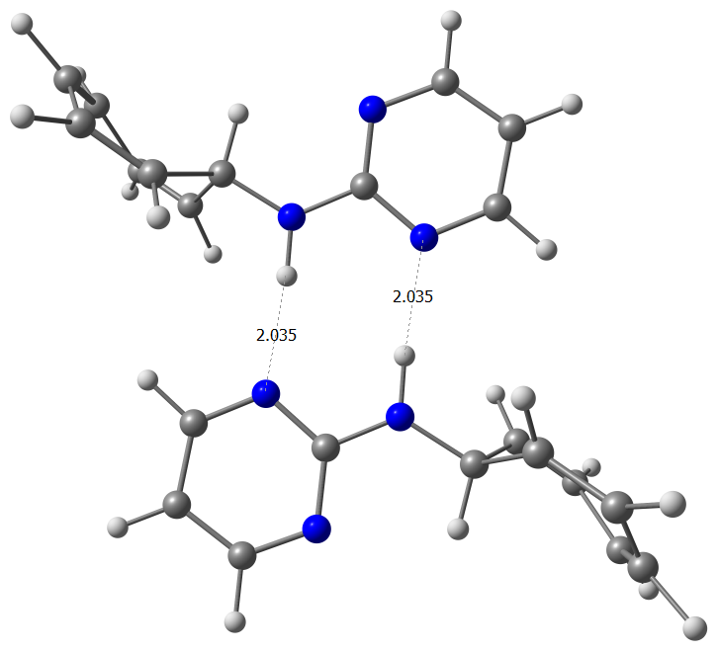
Атом x y z
N -0.427469560 -1.889033018 0.000000000
N 0.427469560 1.889033018 0.000000000
H 0.302639698 -1.172140560 0.000000000
H -0.302639698 1.172140560 0.000000000
N -2.702009092 -2.372358650 0.000000000
N 2.702009092 2.372358650 0.000000000
N 1.880803853 0.112241139 0.000000000
N -1.880803853 -0.112241139 0.000000000
C -1.707651857 -1.460048164 0.000000000
C 1.707651857 1.460048164 0.000000000
C 3.138893043 -0.322213281 0.000000000
C -3.138893043 0.322213281 0.000000000
H 3.266256545 -1.404559648 0.000000000
H -3.266256545 1.404559648 0.000000000
C -4.240384455 -0.529989235 0.000000000
C 4.240384455 0.529989235 0.000000000
H 5.258038848 0.159214052 0.000000000
H -5.258038848 -0.159214052 0.000000000
C -3.940657663 -1.892311716 0.000000000
C 3.940657663 1.892311716 0.000000000
H -4.736732591 -2.637015185 0.000000000
H 4.736732591 2.637015185 0.000000000
C -0.018040725 -3.276983283 0.000000000
C 0.018040725 3.276983283 0.000000000
H -0.924745547 -3.892291636 0.000000000
H 0.924745547 3.892291636 0.000000000
C 0.820002933 -3.621502978 -1.210424823
C -0.820002933 3.621502978 1.210424823
C 0.820002933 -3.621502978 1.210424823
C -0.820002933 3.621502978 -1.210424823
H 1.142637179 -2.800791259 -1.848353381
H -1.142637179 2.800791259 1.848353381
H 1.142637179 -2.800791259 1.848353381
H -1.142637179 2.800791259 -1.848353381
C 1.131487825 -4.898209579 -1.523286712
C -1.131487825 4.898209579 1.523286712
C 1.131487825 -4.898209579 1.523286712
C -1.131487825 4.898209579 -1.523286712
H 1.631373832 -5.089523308 -2.471864255
H -1.631373832 5.089523308 2.471864255
H 1.631373832 -5.089523308 2.471864255
H -1.631373832 5.089523308 -2.471864255
C 0.884875637 -6.047521961 -0.682725319
C -0.884875637 6.047521961 0.682725319
C 0.884875637 -6.047521961 0.682725319
C -0.884875637 6.047521961 -0.682725319
H 0.826199110 -7.013419429 -1.182092124
H -0.826199110 7.013419429 1.182092124
H 0.826199110 -7.013419429 1.182092124
H -0.826199110 7.013419429 -1.182092124
TOTAL ENERGY = -1179.533981.

S10. Вид, координаты (Å) и значение полной энергии (a.u.) ассоциата 2*2, оптимизированного методом DFT/PBE0/6-31G(d,p)
View, Cartesian coordinates (Å) and total energy value (a.u.) of associate 2*2 optimized at the DFT/PBE0/6-31G(d,p) level.

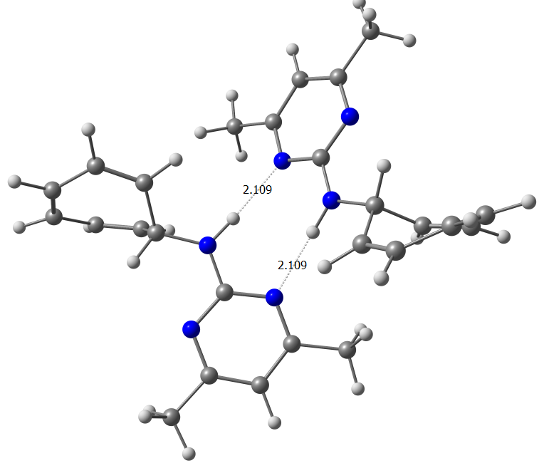

Атом x y z
H -1.157237340 -0.194289185 0.300475162
H 1.157237340 0.194289185 0.300475162
N -2.087109070 2.883449370 0.095325886
N 2.087109070 -2.883449370 0.095325886
N -0.002082403 -1.896310304 0.764277222
N 0.002082403 1.896310304 0.764277222
N -1.728620241 0.595841510 -0.002159313
N 1.728620241 -0.595841510 -0.002159313
C -1.268536443 1.835100189 0.296358982
C 1.268536443 -1.835100189 0.296358982
C -3.059905414 0.334312827 -0.505666852
C 3.059905414 -0.334312827 -0.505666852
H -3.402041731 1.232335068 -1.033924961
H 3.402041731 -1.232335068 -1.033924961
C 0.320577898 -4.256513486 0.931430157
C -0.320577898 4.256513486 0.931430157
H -0.058654871 -5.236328080 1.198257016
H 0.058654871 5.236328080 1.198257016
C -0.460399862 -3.108670341 1.092244435
C 0.460399862 3.108670341 1.092244435
C -1.604266585 4.088808798 0.404414230
C 1.604266585 -4.088808798 0.404414230
C -3.055479043 -0.838942875 -1.454730449
C 3.055479043 0.838942875 -1.454730449
H -2.141313434 -1.424428710 -1.530319494
H 2.141313434 1.424428710 -1.530319494
C -4.062822961 0.009747871 0.580826879
C 4.062822961 -0.009747871 0.580826879
H -3.678909679 -0.126991587 1.589835764
H 3.678909679 0.126991587 1.589835764
C -4.123565557 -1.139867737 -2.225427546
C 4.123565557 1.139867737 -2.225427546
H -4.011430866 -1.921375454 -2.975691838
H 4.011430866 1.921375454 -2.975691838
C -2.523169644 5.254936887 0.162560586
C 2.523169644 -5.254936887 0.162560586
H -3.457038920 5.114734050 0.715717755
H 3.457038920 -5.114734050 0.715717755
H -2.069015418 6.201965476 0.463121705
H 2.069015418 -6.201965476 0.463121705
H -2.785726667 5.307971591 -0.898947583
H 2.785726667 -5.307971591 -0.898947583
C -5.388389364 -0.069053927 0.333547368
C 5.388389364 0.069053927 0.333547368
H -6.066259984 -0.181090591 1.178769732
H 6.066259984 0.181090591 1.178769732
C -5.995051865 -0.048221044 -0.977908225
C 5.995051865 0.048221044 -0.977908225
H -7.039615011 0.255814027 -1.026974716
H 7.039615011 -0.255814027 -1.026974716
C -1.859628980 -3.179188692 1.640341077
C 1.859628980 3.179188692 1.640341077
H -2.582397901 -2.824190712 0.898476857
H 2.582397901 2.824190712 0.898476857
H -2.127653257 -4.198412952 1.927598742
H 2.127653257 4.198412952 1.927598742
H -1.951223762 -2.529975413 2.516897436
H 1.951223762 2.529975413 2.516897436
C -5.429121531 -0.528788750 -2.123812435
C 5.429121531 0.528788750 -2.123812435
H -6.059519369 -0.576250139 -3.010494190
H 6.059519369 0.576250139 -3.010494190
TOTAL ENERGY = -1336.765538.

S11. Вид, координаты (Å) и значение полной энергии (a.u.) ассоциата 3*3, оптимизированного методом DFT/PBE0/6-31G(d,p)
View, Cartesian coordinates (Å) and total energy value (a.u.) of associate 3*3 optimized at the DFT/PBE0/6-31G(d,p) level.

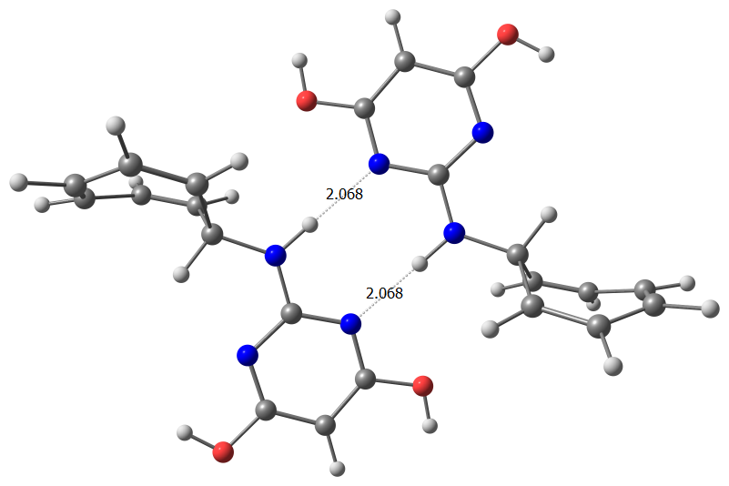

Атом x y z
N 1.923752355 -0.495056981 0.003592485
N -1.923752355 0.495056981 0.003592485
H 1.263310158 0.276607758 0.122196131
H -1.263310158 -0.276607758 0.122196131
N -2.277915516 2.783834392 0.133408779
N 2.277915516 -2.783834392 0.133408779
N -0.089606533 1.824167295 0.350848026
N 0.089606533 -1.824167295 0.350848026
C -1.428355891 1.737908246 0.168905597
C 1.428355891 -1.737908246 0.168905597
C 0.399099184 3.045666326 0.523643957
C -0.399099184 -3.045666326 0.523643957
C -0.375360497 4.207305767 0.513296000
C 0.375360497 -4.207305767 0.513296000
H 0.024511639 5.203434464 0.655405847
H -0.024511639 -5.203434464 0.655405847
C -1.736719500 3.983752582 0.300057071
C 1.736719500 -3.983752582 0.300057071
C 3.327083475 -0.199075273 -0.193291494
C -3.327083475 0.199075273 -0.193291494
H 3.830812431 -1.136850569 -0.452398839
H -3.830812431 1.136850569 -0.452398839
C 3.998062275 0.381256334 1.030362111
C -3.998062275 -0.381256334 1.030362111
C 3.546502753 0.797302786 -1.303985911
C -3.546502753 -0.797302786 -1.303985911
H 3.361670535 0.714330313 1.846559248
H -3.361670535 -0.714330313 1.846559248
H 2.683022325 1.339121646 -1.682033831
H -2.683022325 -1.339121646 -1.682033831
C 5.343926174 0.467344180 1.115119906
C -5.343926174 -0.467344180 1.115119906
C 4.774318037 0.995718520 -1.832053806
C -4.774318037 -0.995718520 -1.832053806
H 5.786076794 0.776387185 2.061433328
H -5.786076794 -0.776387185 2.061433328
H 4.862962447 1.632234065 -2.711444250
H -4.862962447 -1.632234065 -2.711444250
C 6.260505154 0.223105557 0.024970752
C -6.260505154 -0.223105557 0.024970752
C 6.005328629 0.460899327 -1.296626705
C -6.005328629 -0.460899327 -1.296626705
H 7.282153655 -0.041046356 0.294885986
H -7.282153655 0.041046356 0.294885986
H 6.840600651 0.369957702 -1.989656339
H -6.840600651 -0.369957702 -1.989656339
O -2.567172078 5.036442723 0.263983397
O 2.567172078 -5.036442723 0.263983397
H -3.449255310 4.668214835 0.114699660
H 3.449255310 -4.668214835 0.114699660
O 1.734996209 3.074761485 0.709278169
O -1.734996209 -3.074761485 0.709278169
H 2.022439524 3.988612354 0.803342192
H -2.022439524 -3.988612354 0.803342192
TOTAL ENERGY = -1480.330659.

